NJ-ISE ADFS Configuration Guide
Configuration Guide
Prepared for
New Jersey Information Sharing Environment NJ-ISE
Monday, 12 May 2014
Version 1.1 Draft
Prepared by
Don Dinulos
Sr. Consultant
don.dinulos@microsoft.com

Table of Contents
1 ADFS Server Role Installation 2
1.1 Assumption Made 2
1.2 Prerequisites 3
1.2.1 To enable Application Server Role 3
1.2.2 Turn off Windows Firewall on ise-portal-01 7
1.2.3 Create DNS entry 9
1.2.4 Create Server Certificate 9
2 Configure Relying Party Trust with SharePoint 10
2.1 Active Directory (AD) Attribute Store 10
2.2 Configure SharePoint 28
2.2.1 Exporting the Token Signing Certificates 28
2.2.2 Configuring SharePoint using Power Shell 31
2.2.3 Configure SharePoint Identity Provider 33
2.2.4 Set Up SQL Server Attribute Store 35
3 Configure GTRI Reference SP as Relying Party (On-boarding SPs) 37
3.1.1 Configure Relying Party Trust 37
3.1.2 Add Claim Rules 40
3.1.3 Configure Assertion and Response Signing 42
3.1.4 Configure Certificate Revocation Check 42
3.1.5 Testing the AD FS IdP with GFIPM Reference SP 42
4 Configure Claims Provider Trust with Partner IdP (On-boarding IDPs) 48
5 Claims Management App 57

- ADFS Server Role Installation
  - Assumption Made
- Base OS Windows Server 2012 (R2) x64 has been installed
- All security patches have been installed
- You have at least 40GB on C: drive
- One setup account as local administrator has been created and you will logon as this account to do all setup
- Service account <Domain>\ADFSAccount has been created and is NOT a local/domain administrator of the server.
- Internet connection is available on the computer
- All needed software are downloaded
- Minimum Server(s) Information. These can be installed in a single dev machine for a development environment, although not recommended:
  - AD
  - ADFS
  - SharePoint
  - SQL Server

  - Prerequisites
    - To enable Application Server Role
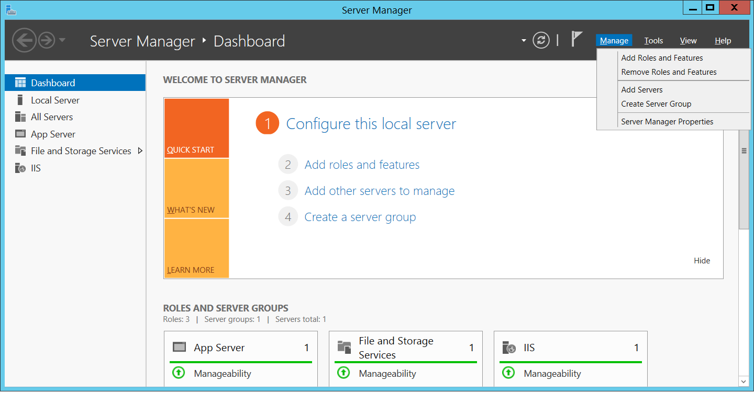
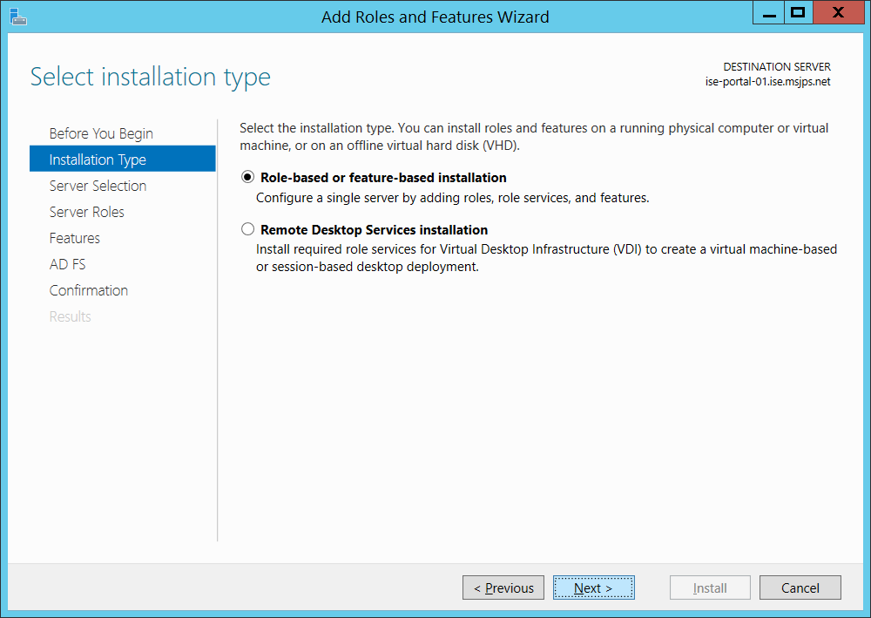
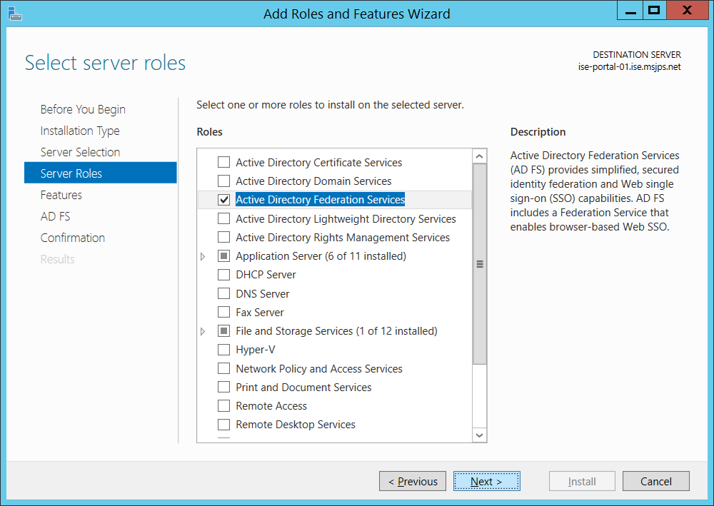
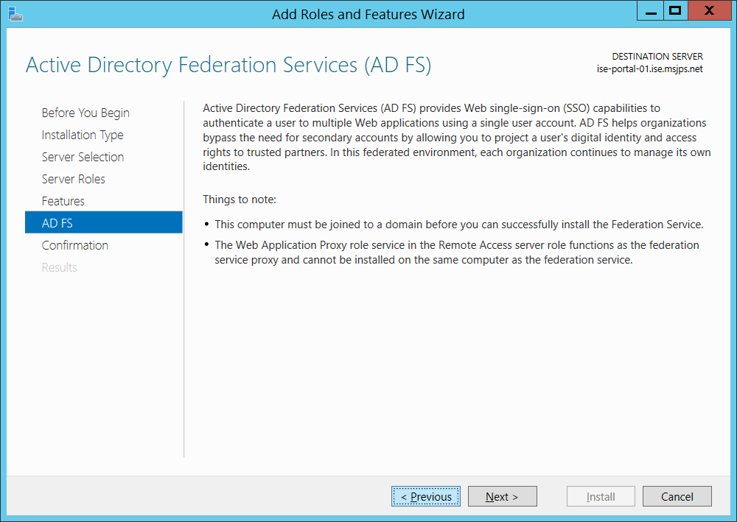
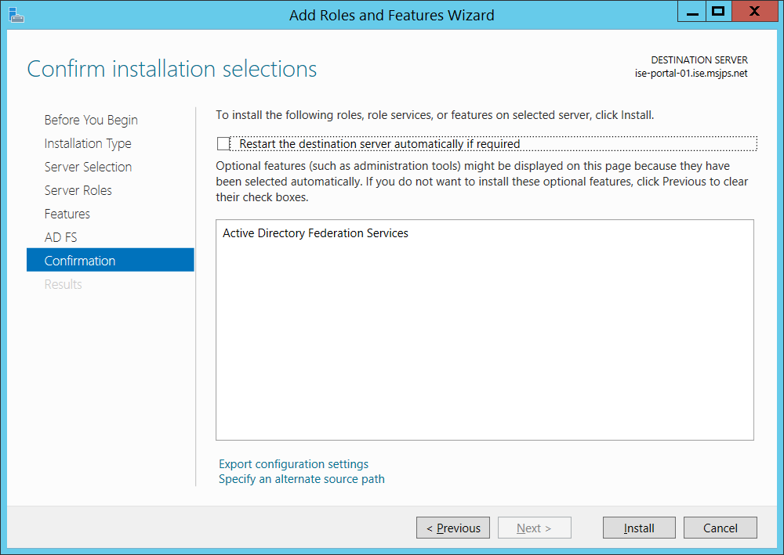
    - Turn off Windows Firewall on ise-portal-01
- Go to control panel, select windows Firewall, select Turn Windows Firewall on or off, select off for all locations and click OK
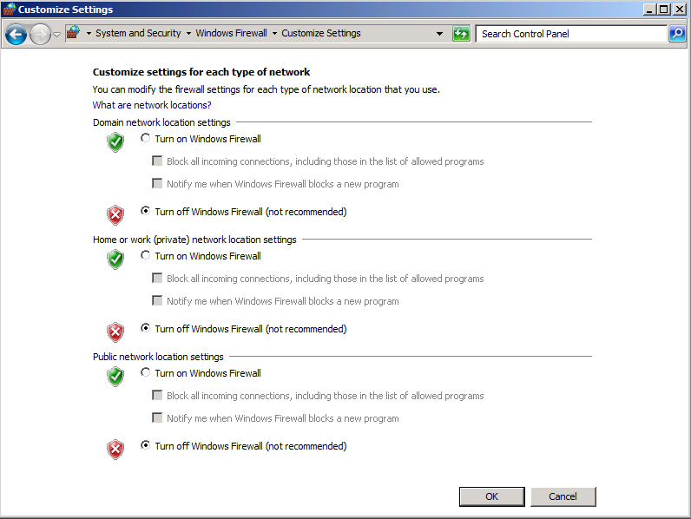

    - Create DNS entry
- Create the following DNS enteries
  - adfs.ise.msjps.net pointing to 10.1.1.14
  - portal.ise.msjps.net pointing to 10.1.1.15
    - Create Server Certificate
- Create and install the following certificates
  - *.ise.msjps.net install on 10.1.1.14
  - *.ise.msjps.net install on 10.1.1.14

- Configure Relying Party Trust with SharePoint
To enable SharePoint to be claims-aware, a Relying Party Trust needs to be configured between the Identity Provider and SharePoint (Relying Party).
  - Active Directory (AD) Attribute Store
The attributes that are needed for SharePoint will all be in AD. For ADFS to extract the attributes from the AD Store, rules need to be created in ADFS. To do this, access the Wizard and create a Relying Party Trust. The SharePoint Site will utilize a “_trust” folder that will be generated once the site is configured to accept claims. Therefore in the relying party WS-Federation Passive Protocol URL, the appropriate URL must be entered. For example: https://portal.njise.msjps.com/_trust/ Assumption: The SharePoint site has been configured and SSL has been enabled. The SharePoint configuration details should be documented in the SharePoint Build Document.

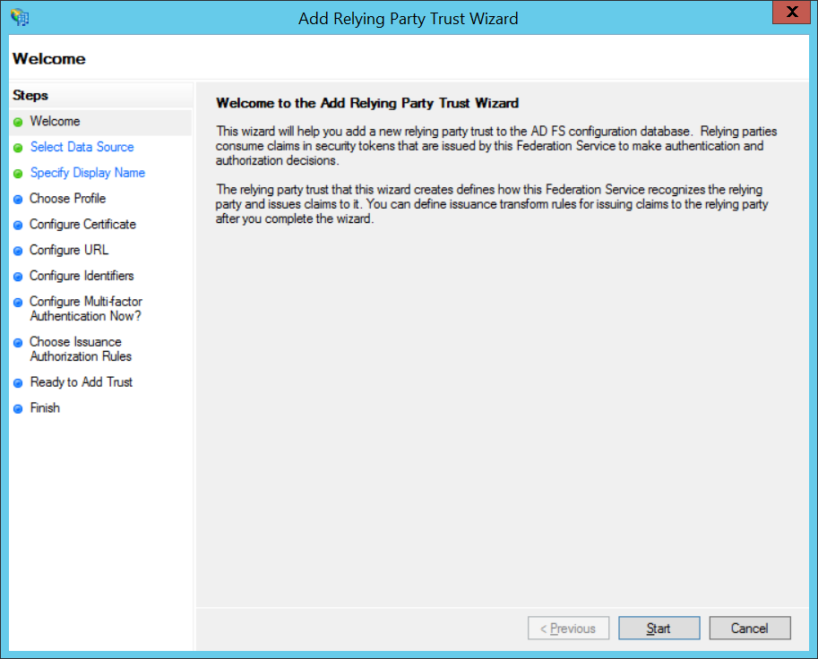
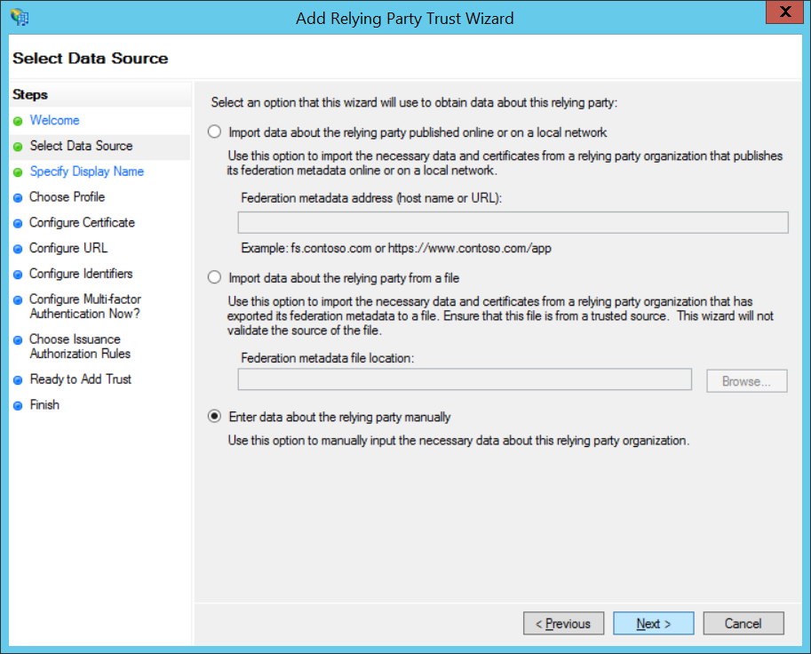

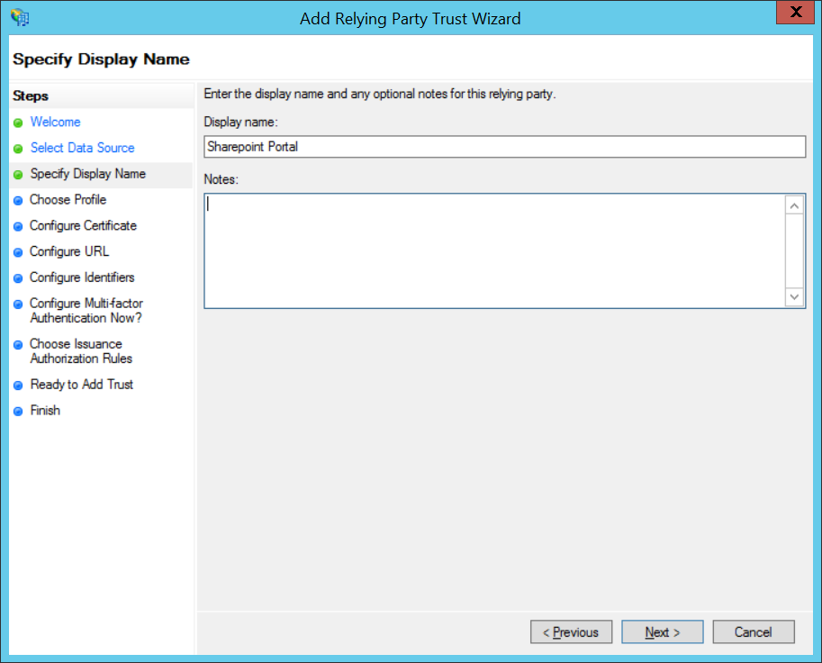
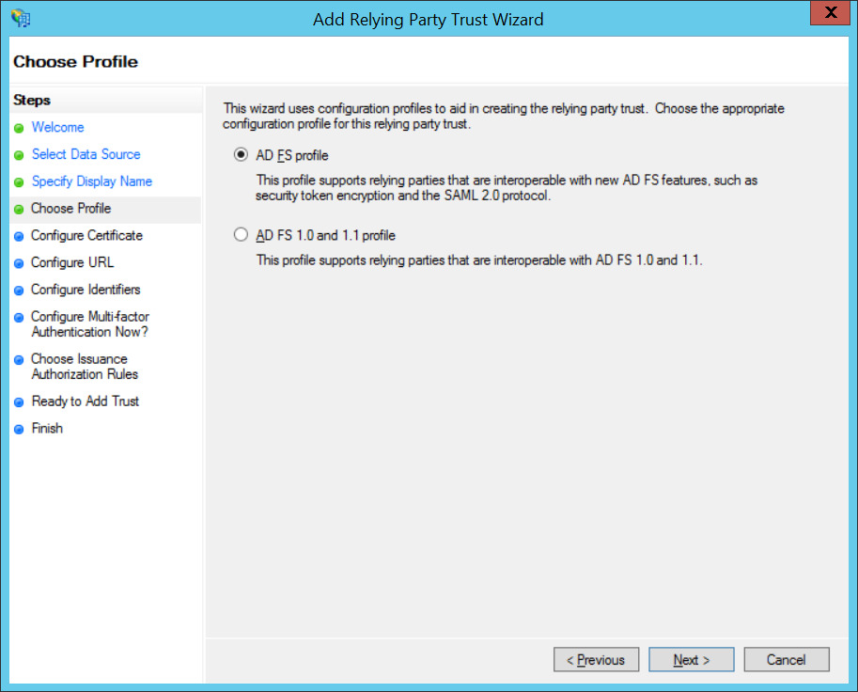
Skip this next screen.
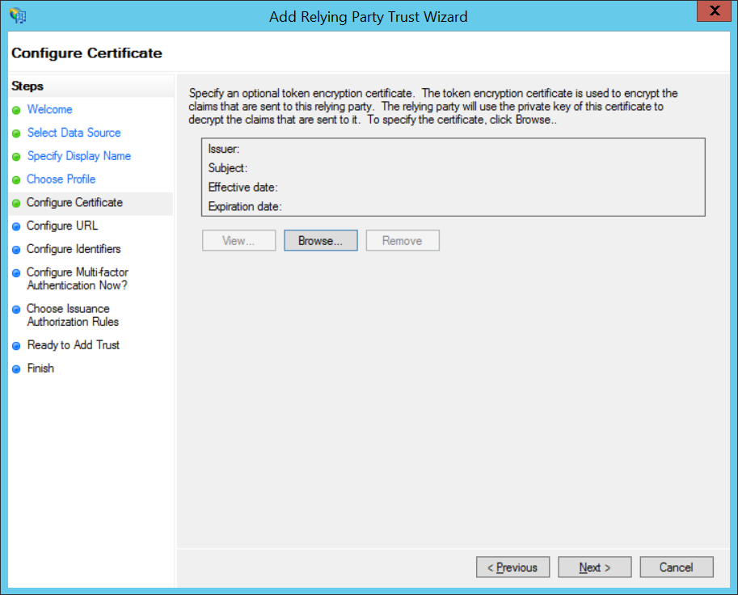

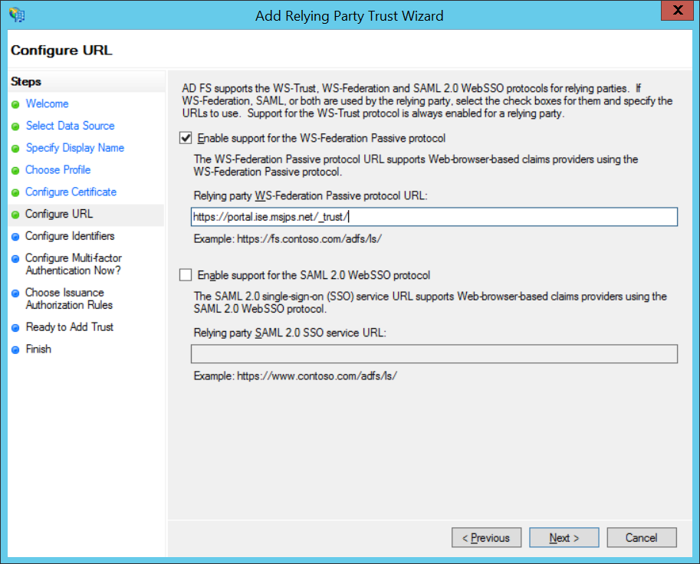
Also add a unique identifier which will be used when configuring the SharePoint realm later. For example: urn:SharePoint:ise.
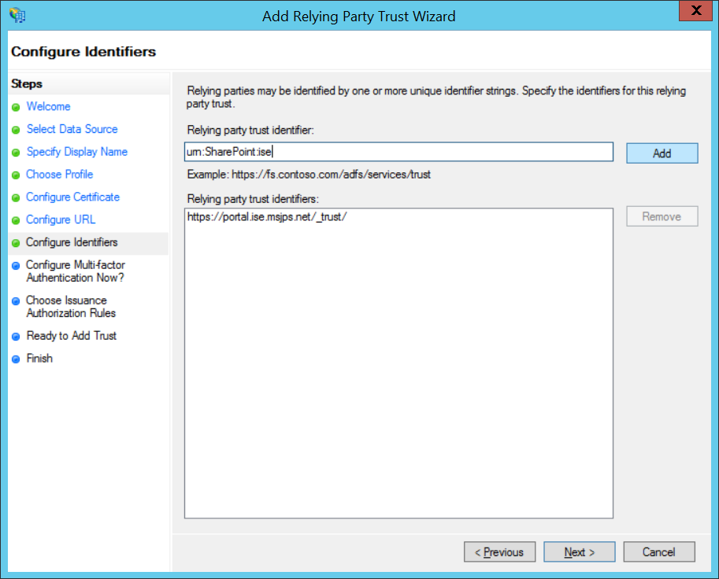
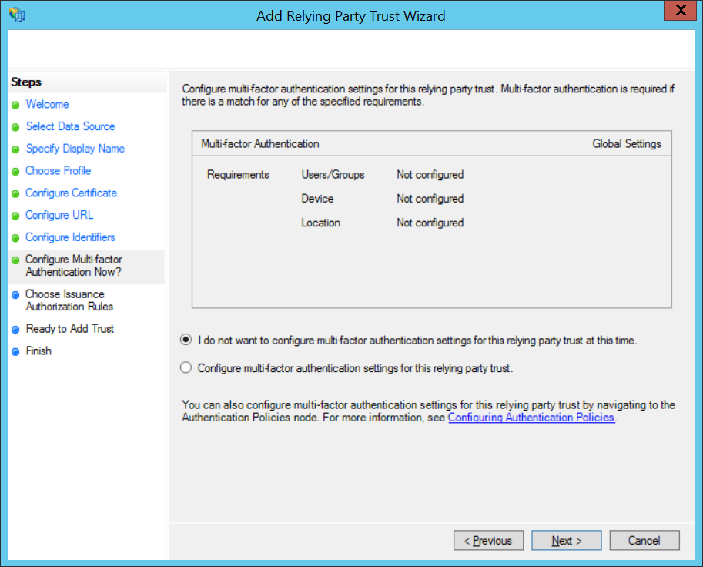
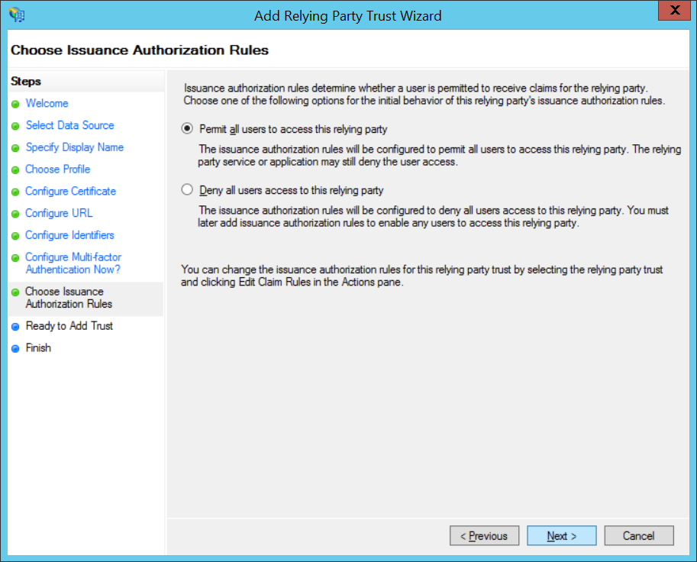

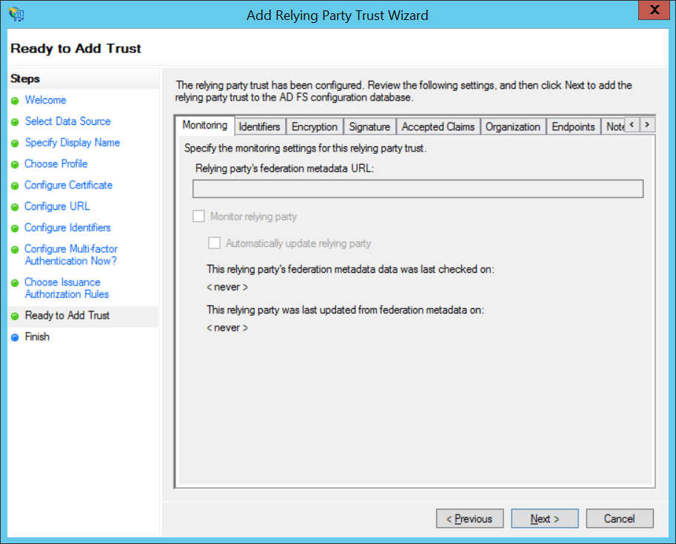

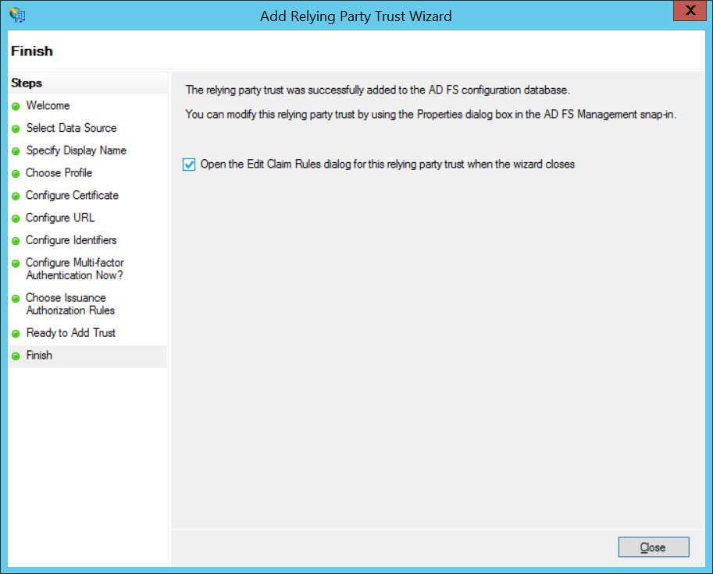

After the relying party trust is created, the claim rules should be created in order to pass the claims from the Active Directory Attribute Store into SharePoint. Leave the “Open the Edit Claims Rule checked”. This will open a new window to add the claim rules.
Click on Add Rules to Add New Rules. Typically, the Send LDAP Attributes as Claims template will be the template used to extract the claims from AD. However, some attributes are not available through this template, the Custom Rule Template should be used to create these attributes. The Custom Rule can be created using the Claim Rules Language. Examples of each scenario are provided below:
c:[Type == "http://schemas.microsoft.com/ws/2008/06/identity/claims/windowsaccountname", Issuer == "AD AUTHORITY"]
=> issue(store = "Active Directory", types = ("http://schemas.xmlsoap.org/ws/2005/05/identity/claims/federationid"), query = ";FederationId;{0}", param = c.Value);

Setting up AD Attributes
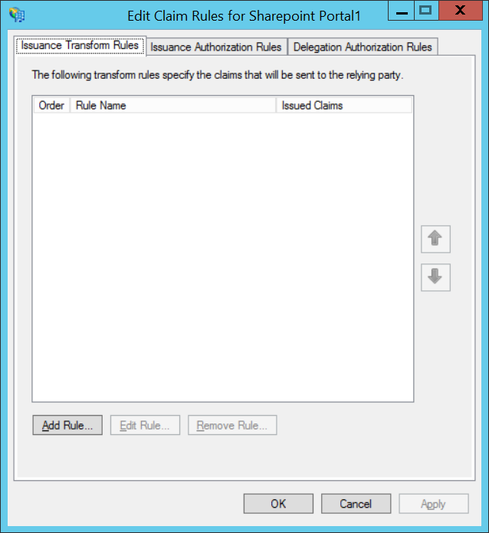
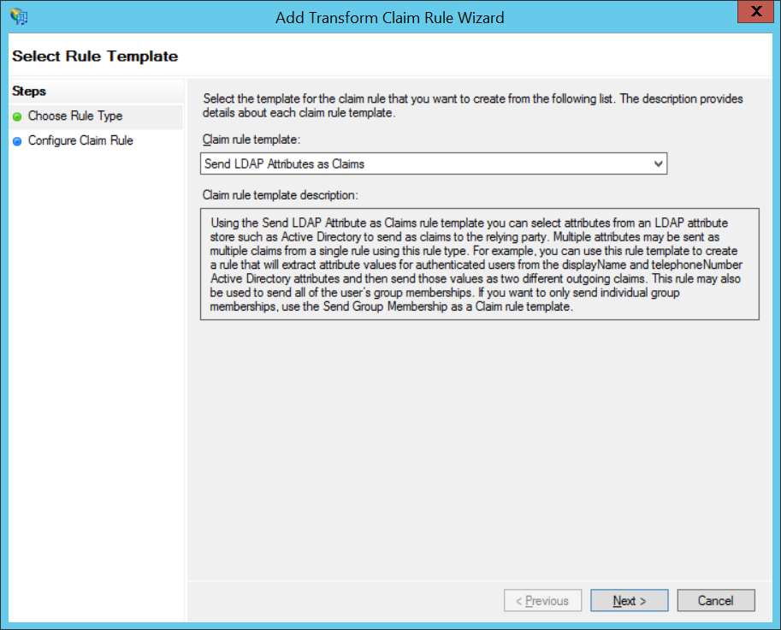

Next, select the following attributes.
Note: Not all of the AD attributes are available in this template (such as Middle Name and Last Logon Date). The Custom Rules should be used for configuring those not listed.
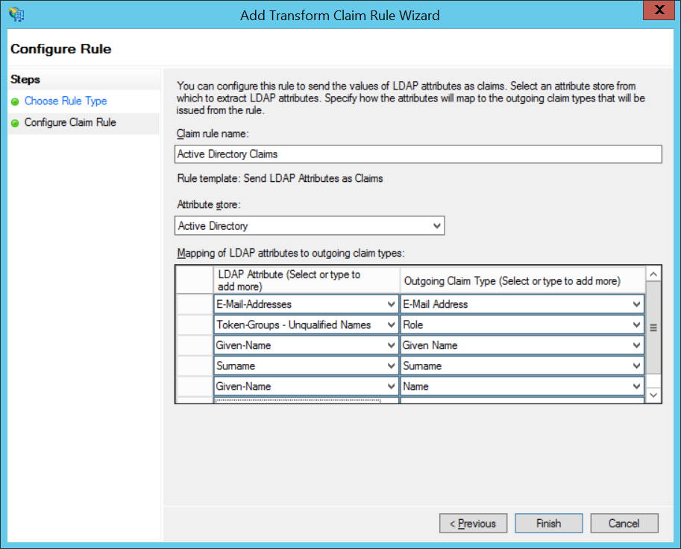

Setting up Static Attributes
Static attrributes should be configured for the Federation Id and Advanced Authentication. Since these attributes are not tied to a user thus doesn’t make sense to add it to the AD. These attributes will be configured using the same Custom Rules Template. Note: the static custom rules can only issue one claim at a time.

Create a new Custom Rule and Enter “Static Claims – Agency Id” and the following under the Rule.
c:[Type == "http://schemas.microsoft.com/ws/2008/06/identity/claims/windowsaccountname", Issuer == "AD AUTHORITY"]
=> issue(Type = "http://schemas.xmlsoap.org/ws/2005/05/identity/claims/agencyid", Value = "NJ-ISE");
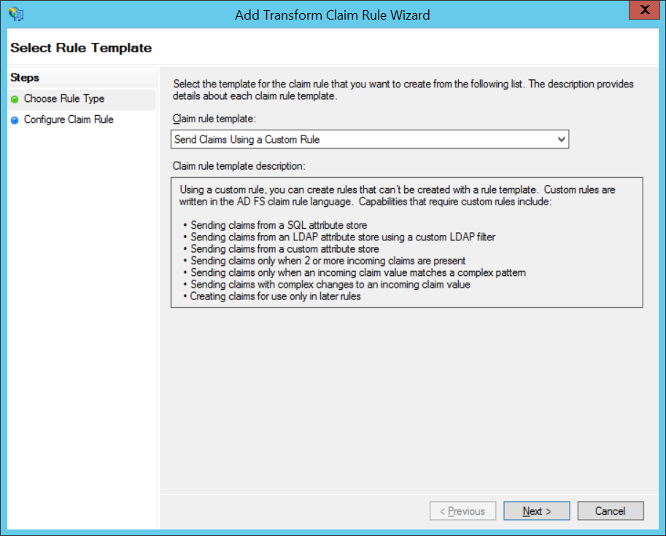
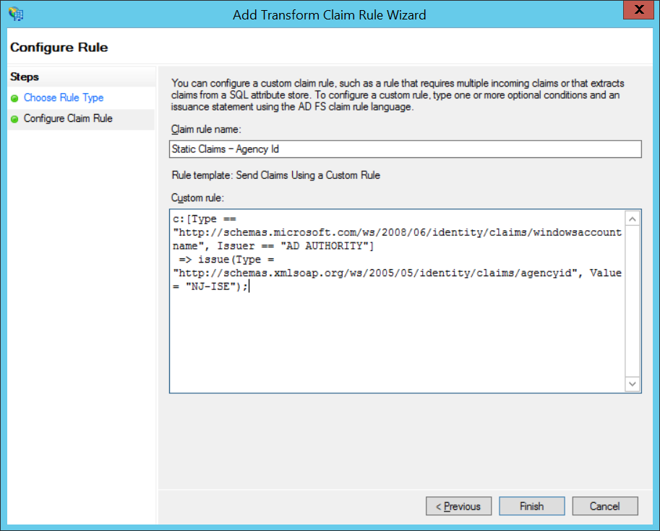
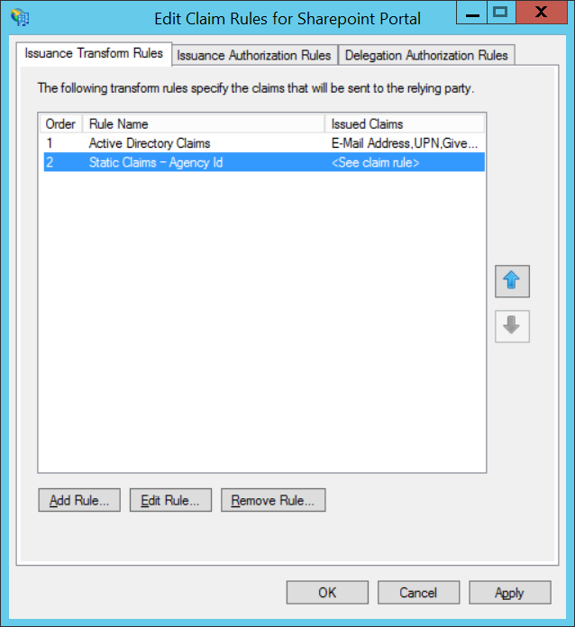

After the claims are set up, click OK. There should be 2 claims created as illustrated below:
The next step is to register and publish the claims in ADFS.
Next, right-click AD FS 2.0\Service\Claim Descriptions of the ADFS Management Console and click Add Claim Description and enter the following information below. Verify both check boxes are checked. Repeat the steps for the rest of the claims to be registered. Only the Agency Id needs to be registred.
http://schemas.xmlsoap.org/ws/2005/05/identity/claims/agencyid
To verify that all the claims are published, open https://federation.njise.msjps.com/federationmetadata/2007-06/federationmetadata.xml in a browser and verify that the claims are their.
The next step is to configure the SharePoint to accept the claims.
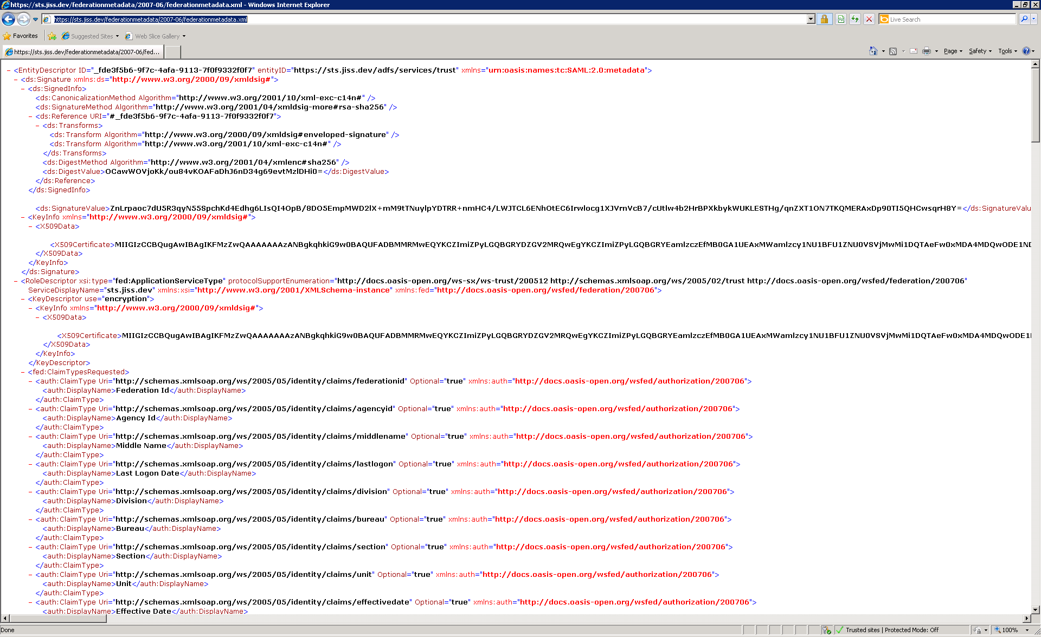

  - Configure SharePoint
    - Exporting the Token Signing Certificates
The Token Signing Certificates must be exported for use by SharePoint. To do this, double-click on the certificate from the ADFS server and click on “Copy to File” and the Certificate Export Wizard will pop up. Next, go through the steps that are displayed and save the .CER file out. Then, copy this file to the SharePoint Server.
Note: Usually a parent certificate must also be exported. This can be verified by going through the Certificate Path containing the certificate details and opening the parent certificate. To export the parent certificate, the same process is followed.
The following screenshots illustrates this process:
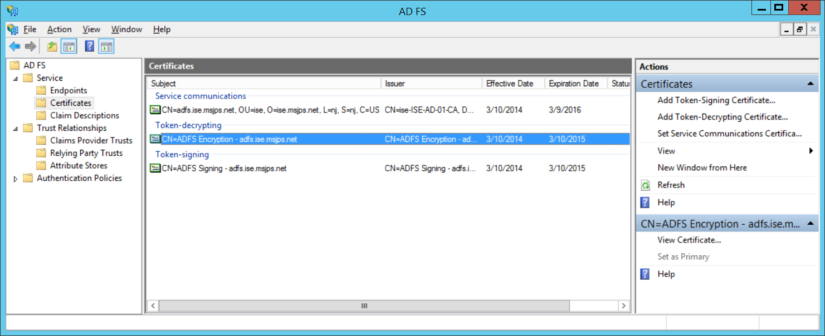

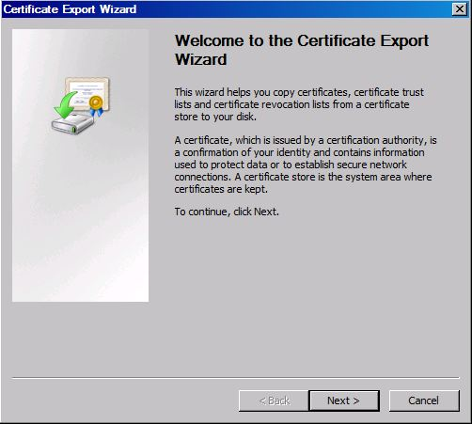
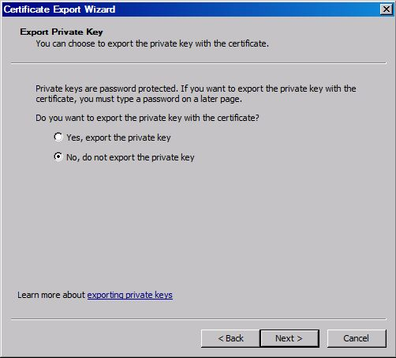
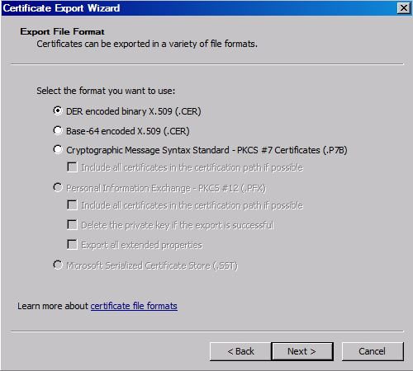
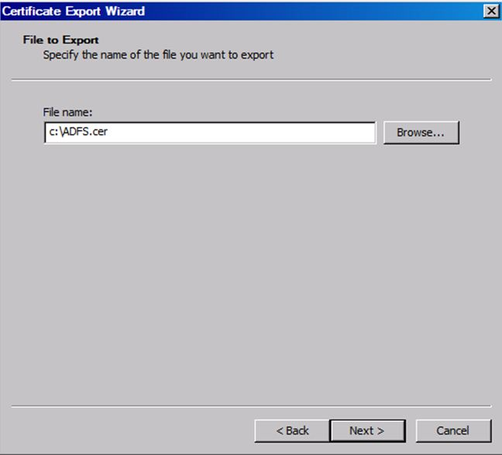

    - Configuring SharePoint using Power Shell
To use configure the ADFS Server as a Trusted Identity Provider in SharePoint, it must be configured through the execution of several scripts in the SharePoint Power Shell Console. Login to the SharePoint Web Front End Server.
Next, open Programs\Microsoft SharePoint 2013 Products\SharePoint 2013 Management Shell as administrator.

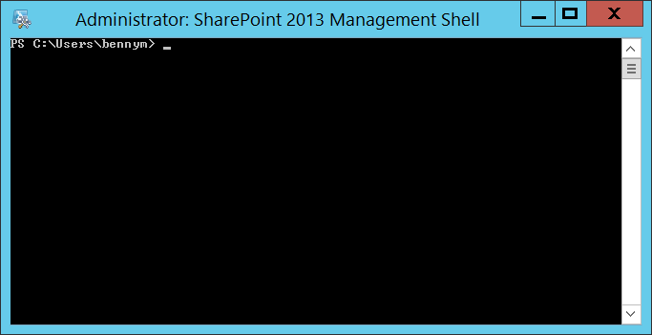

Execute the first step which will remove any existing Trusted Identity Provider. If this Provider has already been used by SharePoint, go to Central Administration and remove the Authentication Provider from that Web Application.
Remove-SPTrustedIdentityTokenIssuer "<name of the existing provider (if any)>"
Next, the certificates that were exported above are registered by executing the following steps:
The command window will appear as illustrated below after the script is executed:
$cert = New-Object System.Security.Cryptography.X509Certificates.X509Certificate2("C:\ISE-ADFS\Certificates\ADFS.cer")
New-SPTrustedRootAuthority -Name "ADFS Token Signing Cert" -Certificate $cert
The next step is to register the claims in SharePoint. Example scripts which are used to map attributes which directs SharePoint to accept those claims are provided below:
Note: All the claims must be registered in SharePoint. Otherwise, SharePoint will drop and ignore them thus it is not available when referencing the claims within the SharePoint application. See below for an example script:
The next step is to create the Identity Provider including all of the associated claims required for configuration.
$map1 = New-SPClaimTypeMapping -IncomingClaimType "http://schemas.microsoft.com/ws/2008/06/identity/claims/upn" -IncomingClaimTypeDisplayName "UPN" -SameAsIncoming
$map2 = New-SPClaimTypeMapping -IncomingClaimType "http://schemas.microsoft.com/ws/2008/06/identity/claims/role" -IncomingClaimTypeDisplayName "Role" -SameAsIncoming
$map3 = New-SPClaimTypeMapping -IncomingClaimType "http://schemas.xmlsoap.org/ws/2005/05/identity/claims/surname" -IncomingClaimTypeDisplayName "Last Name" -SameAsIncoming
$map4 = New-SPClaimTypeMapping -IncomingClaimType "http://schemas.xmlsoap.org/ws/2005/05/identity/claims/givenname" -IncomingClaimTypeDisplayName "First Name" -SameAsIncoming
$map5 = New-SPClaimTypeMapping -IncomingClaimType "http://schemas.xmlsoap.org/ws/2005/05/identity/claims/emailaddress" -IncomingClaimTypeDisplayName "Email Address" -SameAsIncoming
$realm = "urn:SharePoint:ise”
$ap = New-SPTrustedIdentityTokenIssuer -Name "federation.njise.msjps.com" -Description "ADFS" -realm $realm -ImportTrustCertificate $cert -ClaimsMappings $map1,$map2,$map3,$map4,$map5 -SignInUrl " https://federation.njise.msjps.com/adfs/ls" -IdentifierClaim $map5.InputClaimType
    - Configure SharePoint Identity Provider
The next step is to go to SharePoint Central Administration to specify the web application authentication providers to use the newly registered Trusted Identity Provider (adfs.ise.msjps.net), When found, click Save.

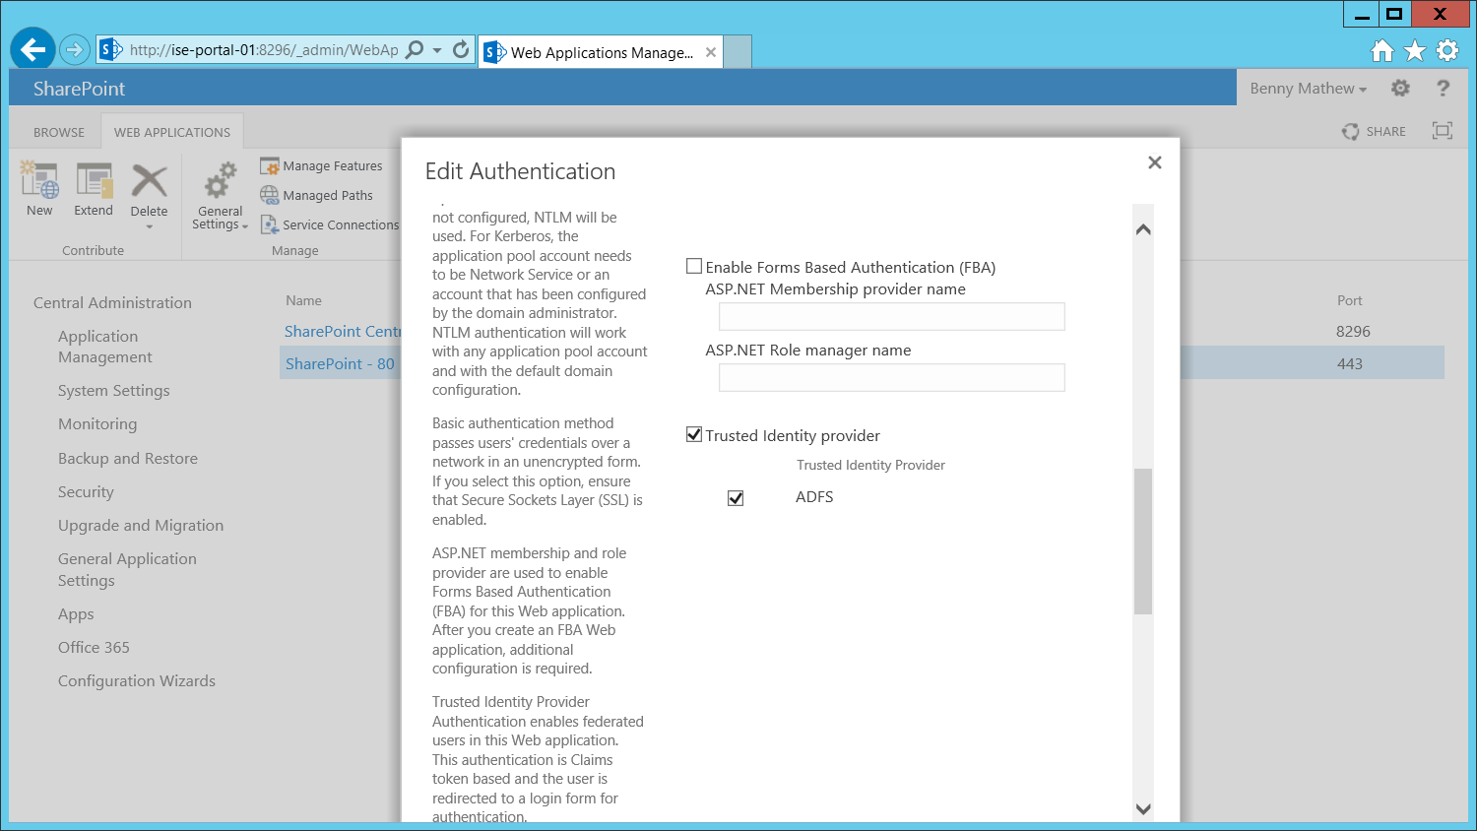

The SharePoint Web Application should be configured to accept the claims from the Identity Provider. When logging in to the site, the Trusted Identity Provider should be in the drop down list as shown below:
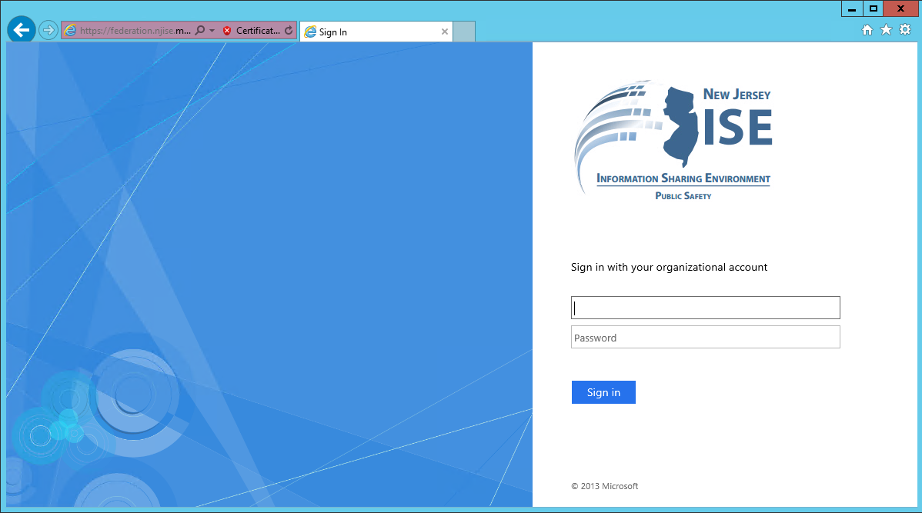
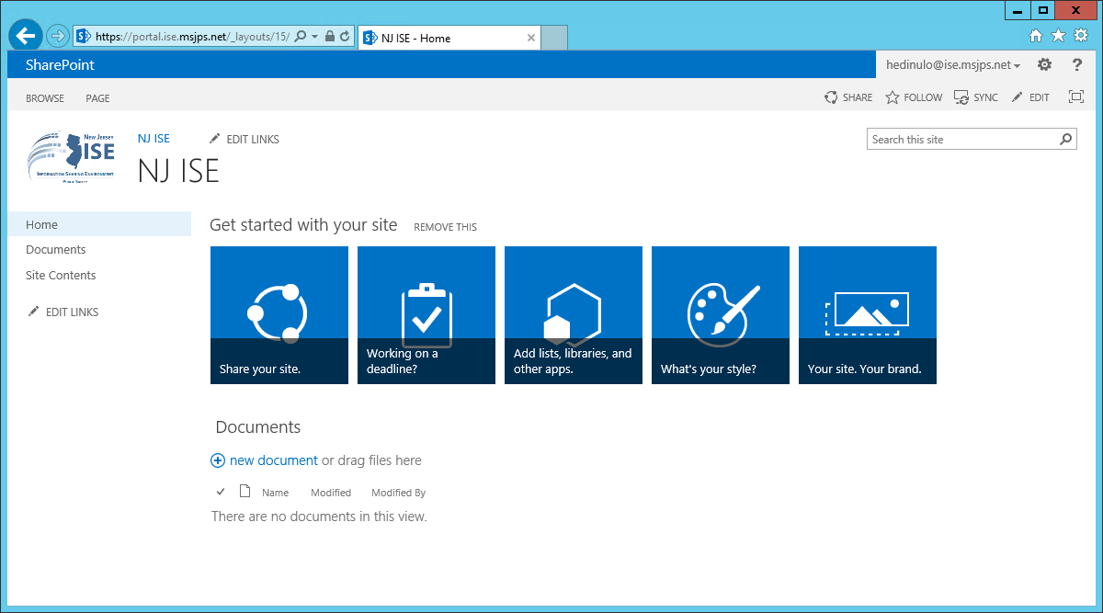

    - Set Up SQL Server Attribute Store
• Create a Database in ISE-PORTAL-01 called “Microsoft.JPS.ClaimsManagementDB”. Make sure <Domain>\ADFSAccount has select/execute rights.
• Start AD FS Management
• Right-click Attribute Stores and select “Add Attribute Stores…”
• Enter a display name (such as ‘Claims Management DB’), select SQL for attribute store type, enter the connection string like database=Microsoft.JPS.ClaimsManagementDB;server=ise-portal-01.cloudapp.net;integrated security=SSPI, and click the OK button. Note: the ADFS Service Account will need select/execute rights to this database.
- Configure GTRI Reference SP as Relying Party (On-boarding SPs)
    - Configure Relying Party Trust
- Get GTRI Reference SP metadata by saving SAML 2 Metadata for the GFIPM Reference Service Provider at https://rhelsp.ref.gfipm.net/ref-sp-metadata.xml to a local file. Note: If using the Trust Fabric, i.e . https://nief.gfipm.net/trust-fabric/nief-trust-fabric.xml, extract the specific information which starts with i.e. <md:EntityDescriptor xmlns:md="urn:oasis:names:tc:SAML:2.0:metadata" entityID="GFIPM:SP:NIEFPortal">. The namespace xmlns:md will need to be added if this is not included and save it as a separate .XML file so ADFS can consume it.
- In AD FS 2.0 Management, expand Trust Relationships, right-click Relying Party Trusts, and Select Add Relying Party Trust to start the wizard.
- Select “Import data about the relying party from a file”. Browse to the metadata file saved in Step 1, and complete the steps.
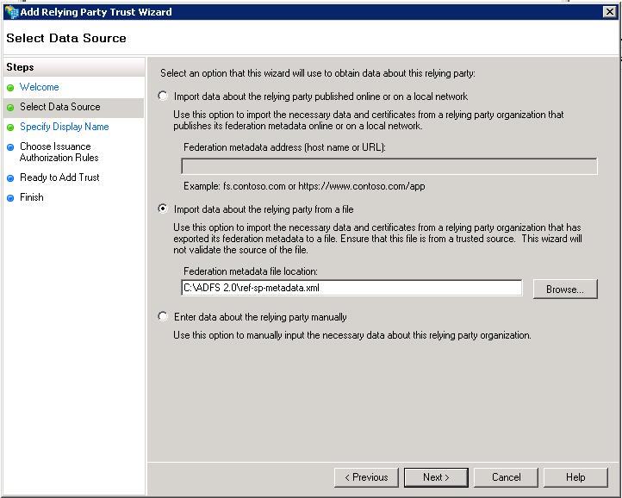
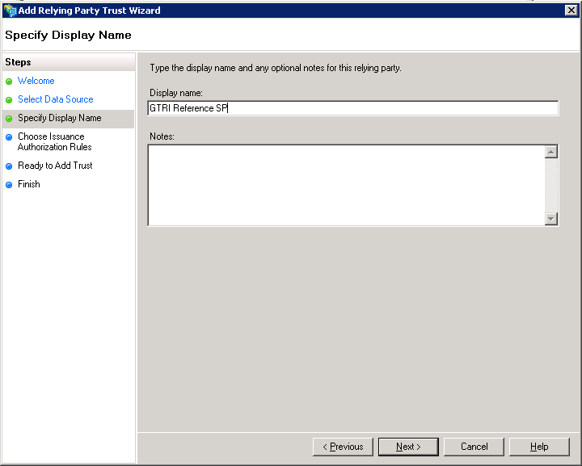
- Set “Secured hash Algorithm” to “SHA-1” in the “Advanced Tab.

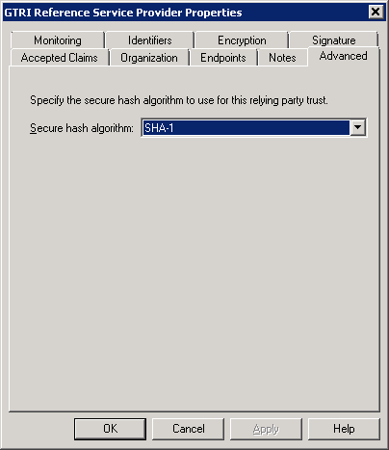

    - Add Claim Rules
- Shibboleth expects SAML attribute names to have a format of urn:oasis:names:tc:SAML:2.0:attrname-format:uri. By default, AD FS issues attributes with a name format of urn:oasis:names:tc:SAML:2.0:attrname-format:unspecified. If there is a mismatch, Shibboleth will ignore the attribute. For each GFIPM attribute, we need to issue it with a modified NameFormat.
- Create a file and named it “GFIPM Passthrough Rules.txt”. Take note of where the file is saved. See attached file. Make sure Word Wrap is disabled.
- Start -> Administrative Tools -> Windows PowerShell Modules, type in the following command:
Add-PSSnapin Microsoft.Adfs.Powershell
Set-ADFSRelyingPartyTrust -TargetName "GFIPM:SP:NIEFPortal" -IssuanceTransformRulesFile "<drive>:\<path>\GFIPM Transformation Rules.txt"
- The following screen shot displays the claim rules for GFIPM attributes that will appear as the SAML assertions sent to the relying party:
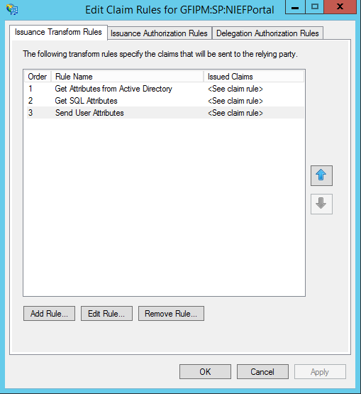

    - Configure Assertion and Response Signing
- By default AD FS does not sign both the SAML Response and SAML Assertion as part of the SSO profile. This is required by the GFIPM Web Browser User-to-System Profile. To configure ADFS to sign both you will need to use a Powershell command:
Add-PSSnapin Microsoft.Adfs.Powershell
Set-ADFSRelyingPartyTrust -TargetName "GFIPM:SP:NIEFPortal" -SamlResponseSignature "MessageAndAssertion"

    - Configure Certificate Revocation Check
- Start -> Administrative Tools -> Windows PowerShell Modules, type in the following command:
Add-PSSnapin Microsoft.Adfs.Powershell
Set-ADFSRelyingPartyTrust -TargetName “GFIPM:SP:NIEFPortal” -EncryptionCertificateRevocationCheck None
Set-ADFSRelyingPartyTrust -TargetName “GFIPM:SP:NIEFPortal” -SigningCertificateRevocationCheck None

    - Testing the AD FS IdP with GFIPM Reference SP
- IdP Initiated https://federation.njise.msjps.com/adfs/ls/idpinitiatedsignon.aspx. Select the GFIPM:NIEF:Portal to sign in.
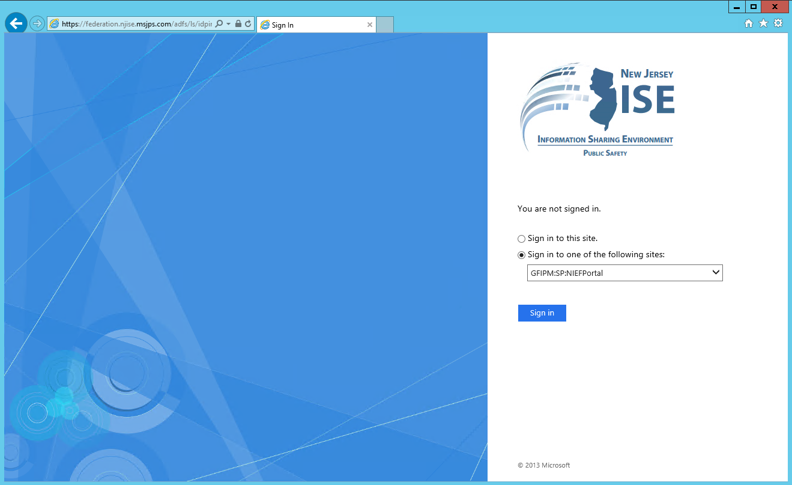
- Enter credentials
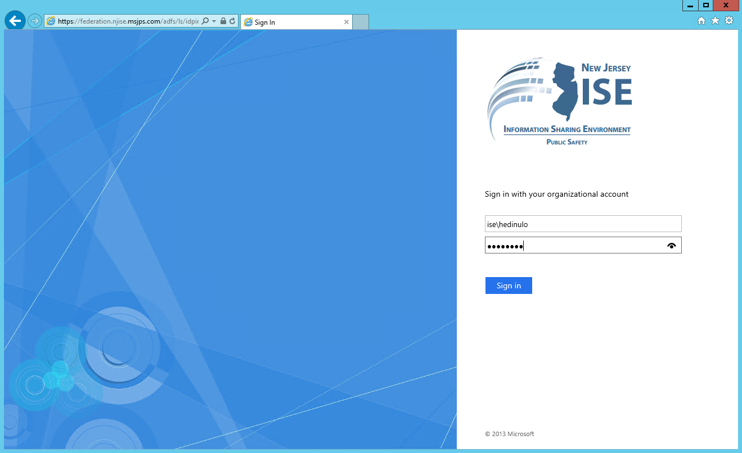

- It’ll take you the GTRI Reference Federation and click on the Test Page.
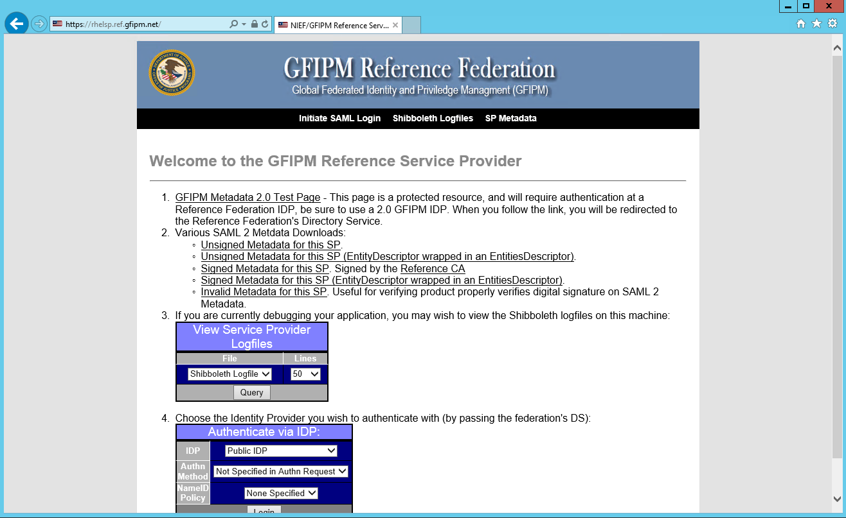
- The attributes should be shown as below.
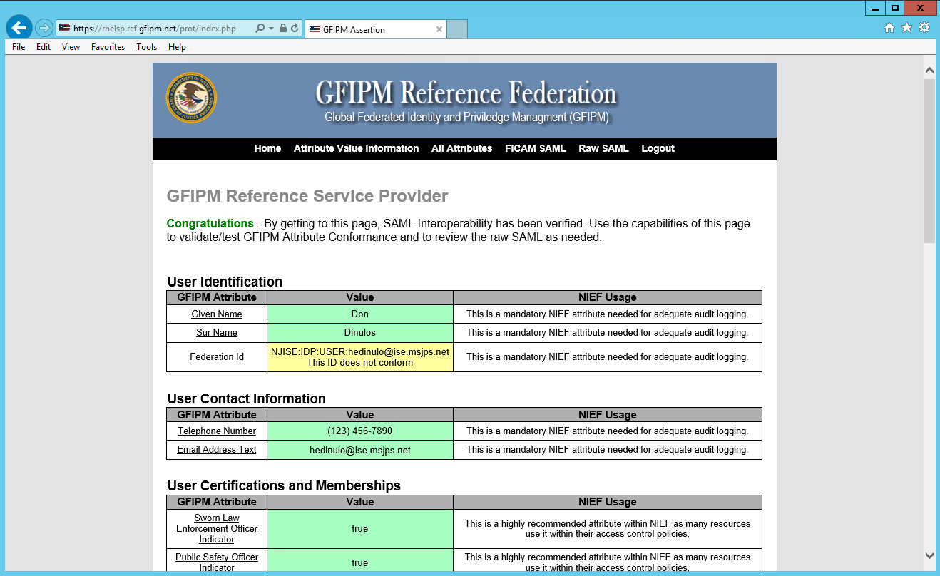

- SP Initiated. Point the browser to https://rhelsp.ref.gfipm.net

Select “NJ-ISE ADFS Test IDP” from the dropdown list and click the “Select” button.
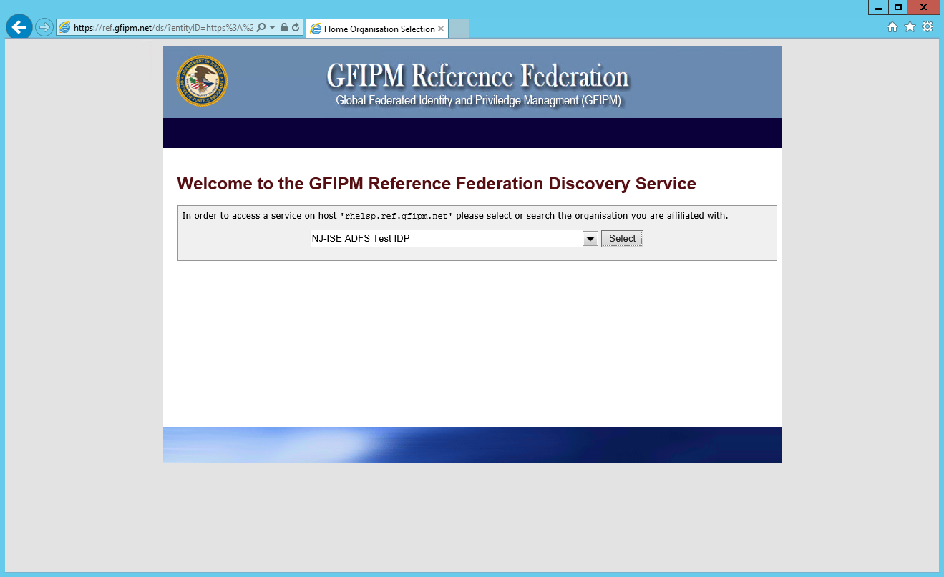
The user will be prompted to sign in.

- After the user signed in, the user will see the page of the reference service provider.

- Configure Claims Provider Trust with Partner IdP (On-boarding IDPs)
NJ-ISE has a Shibboleth IdP where a Federation Trust will need to be established. Any other IdPs will also need to be on-boarded in the same process. A Claims Provider Trust needs to be established with the NJ-ISE AD FS and the Shibboleth IdP which is the Account Provider. This should be a straightforward configuration as well using the federation metadata.
- Open the ADFS 2.0 Management and expand AD FS 2.0\Trust Relationships\Claims Provider Trusts
- Right click, Add Claims Provider Trust
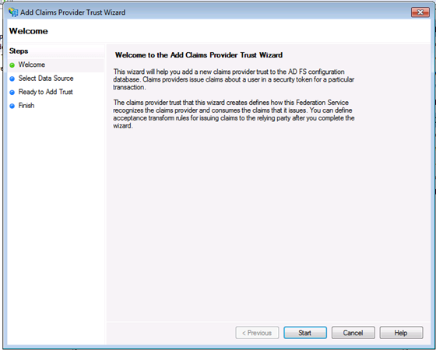
- Select the first option, Import data about the relying party published online or on a local network, and enter the Federation Metadata URL, this is assuming the URL is available. Note: This would be the ideal approach as it downloads the IdP federation information like the attributes exposed, even the certificates are also downloaded automically.
- click Next
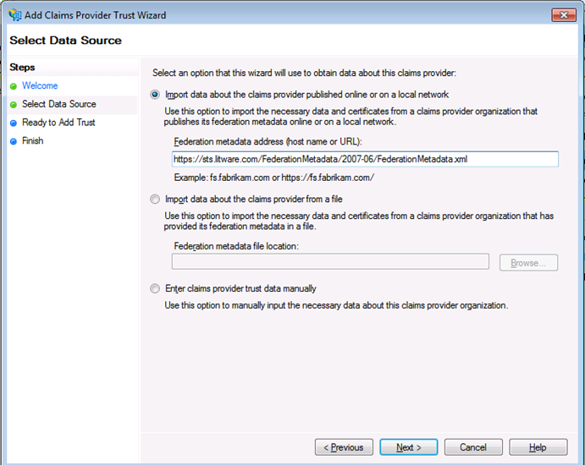
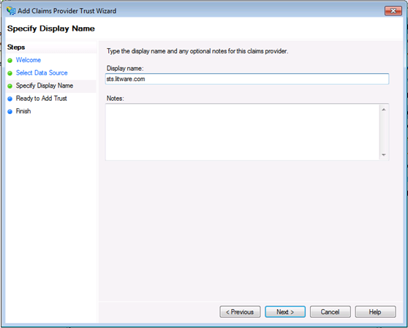
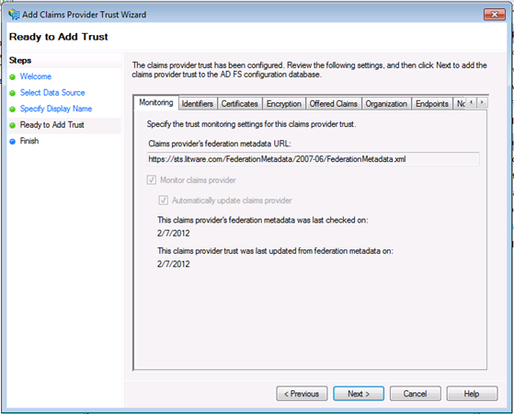
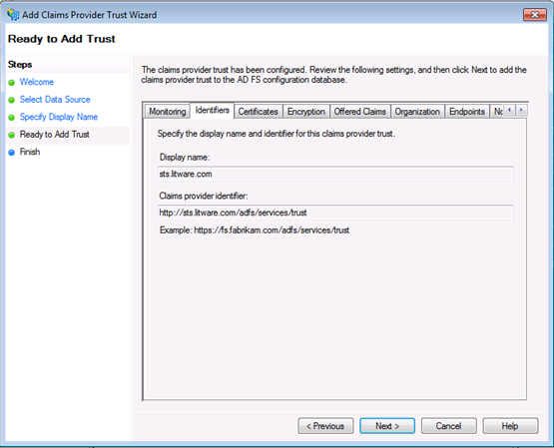
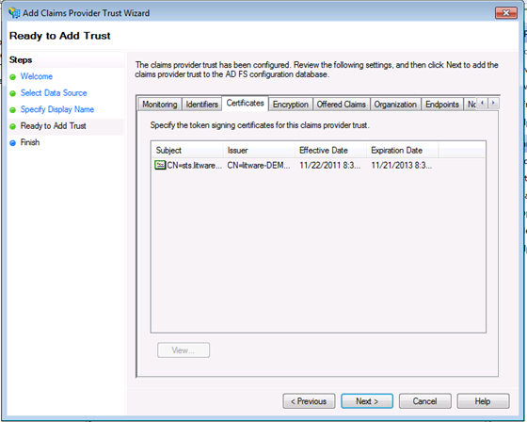

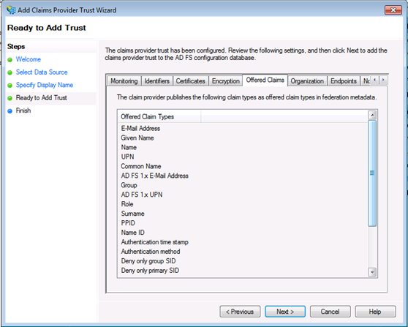
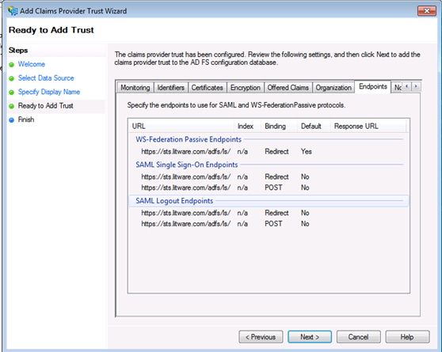

After the claims provider trust is created, the claim rules should be created in order to accept the claims from the NJ-ISE Shibboleth Claims Provider IdP. Leave the “Open the Edit Claims Rule checked”. This will open a new window to add the claim rules.
Same as doing a claims attributes from a relying party, but this time accepting the claims from the Claims Provider as a passthrough claim or doing any transformation if necessary. Below is a screenshot of some claims that can be created:
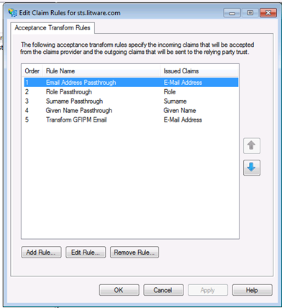
- Claims Management App
In support of the GFIPM attributes that’s needed, a SQL Attribute Store is available and a Claims Management App is available in order to maintain the attribute store database. The User Name is used as the “anchor” attribute to connect the AD user to SQL attribute store. The UPN is used as the anchor attribute. The UPN has this format user@ise.msjps.net, etc.

